**Week One: Design principles & Patterns  
  
Exercise 1: Implementing the Singleton Pattern  
  
CODE:**  
  
package main;

public class Logger {

private static final Logger *instance* = new Logger();

private Logger() {

System.*out*.println("Logger created early.");

}

public static Logger getInstance() {

return *instance*;

}

public void print(String msg) {

System.*out*.println("[LOG] " + msg);

}

public static void main(String[] args) {

Logger a = Logger.*getInstance*();

Logger b = Logger.*getInstance*();

a.print("Loading modules...");

b.print("All modules loaded.");

System.*out*.println(a == b ? "Same logger" : "Different logger");

}

}

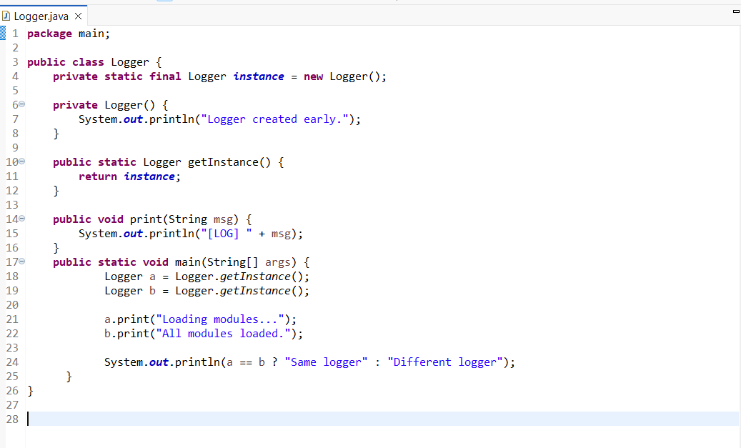

**OUTPUT:**  
  
  
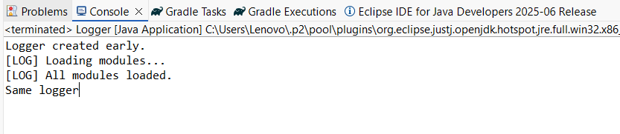

**Exercise 2: Implementing the Factory Method Pattern  
  
CODE:  
  
Interface: Document**

public interface Document {

void show();

}

**Class: PdfDoc**

public class PdfDoc implements Document {

public void show() {

System.out.println("PDF is opened.");

}

}

**Class: ExcelDoc**

public class ExcelDoc implements Document {

public void show() {

System.out.println("Excel file is opened.");

}

}

**Class: WordDoc**

public class WordDoc implements Document {

public void show() {

System.out.println("Word document is opened.");

}

}

**Class: DocumentFactory**

public class DocumentFactory {

public Document getDocument(String type) {

switch (type.toLowerCase()) {

case "pdf":

return new PdfDoc();

case "word":

return new WordDoc();

case "excel":

return new ExcelDoc();

default:

return null;

}

}

}

**Class: MainFactory**

import java.util.Scanner;

public class MainFactory {

public static void main(String[] args) {

Scanner sc = new Scanner(System.in);

DocumentFactory factory = new DocumentFactory();

System.out.print("Enter document type (pdf/word/excel): ");

String input = sc.nextLine();

Document doc = factory.getDocument(input);

if (doc != null) {

doc.show();

} else {

System.out.println("Invalid document type.");

}

sc.close();

}

}

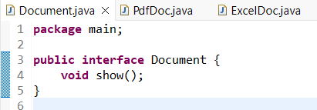

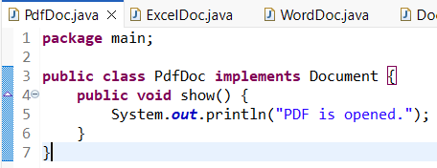  
  
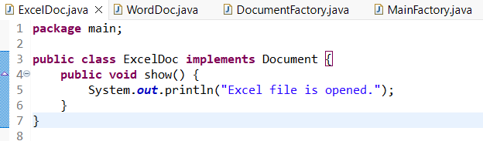  
  
  
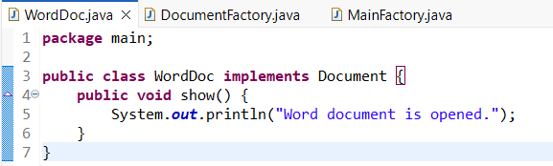  
  
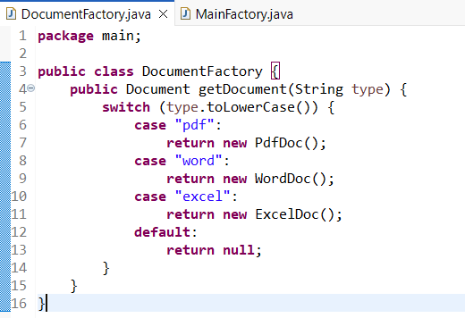  
  
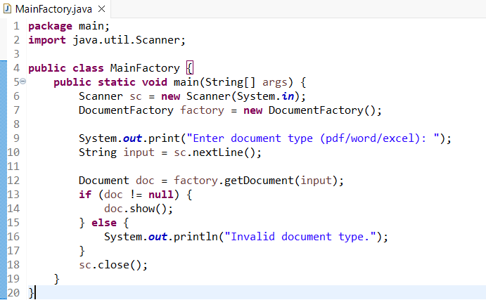  
  
  
  
  
  
  
  
  
  
**OUTPUT:**